Changes from last revision
Date | User | Edits
1/6/2020 | Prof. Levi’s Design Team | USC Release of PTM65 design from GF65 design

Subsystem or block descriptions
Design name | OPAMP in PTM65nm CMOS
The Top-level cell name | Opamp5_PTM65_AllDevices
Designer | Prof. Levi’s Design Team
Organization | University of Southern California

Overview
10bit linearity OPAMP. Originally designed, simulated at 39 PVT corners, fabricated and measured in GF65LPe process.

Block Specifications and Compliance
.
Spec Name | Nominal | Max | Note
Open-loop gain (dB) | 76.12 | N/A | PTM65 has no process corners. Simulated at available corner, 27C, Vdd=1.2V
Fu (MHz) | 99.18 | N/A | PTM65 has no process corners. Simulated at available corner, 27C, Vdd=1.2V
Phase Margin (degrees) | 50.14 | N/A | PTM65 has no process corners. Simulated at available corner, 27C, Vdd=1.2V
Power Consumption (mW) | 9.82 | N/A | Bias set by constant current source, see testbench called test_opamp5_PTM65_AllDevices.
Area (mm²) | N/A | N/A | Only Schematic. No Design Rules available for PTM65.
VDD (Volt) | 1.2V | N/A

Block diagram
Three-stage, differential-input, differential output opamp with common-mode feedback circuit. with power-down control.

Signal list
Symbol, pins and descriptions.

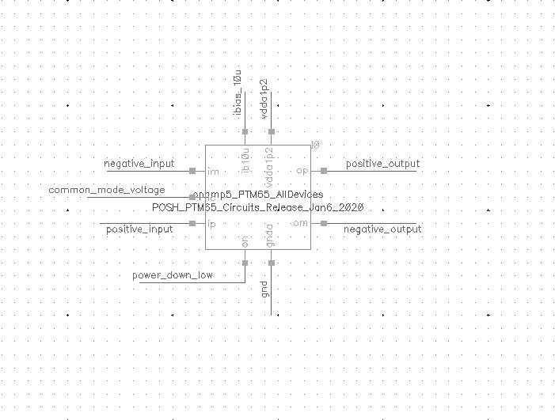
Signal Pins | Direction  (I/O) | Type  (supply, ground, analog current, analog voltage, digital voltage) | Max Voltage  (core, IO or max voltage) | Specification
vdda1p2 | I | Supply | Core | Power Supply, 1.2 V
Gnda | I | Ground | Core | Analog Ground
Ip,im | I | Analog voltage | Core | Differential Analog Input
Op,om | I | Analog voltage | Core | Differential Analog Output
vcm | I | Analog Voltage | Core | Common mode voltage control input
Ib10u | I | Analog Current | Core | Bias current
on | I | Digital Voltage | Core | Power down active low

Design Hierarchy
Symbol, pins and descriptions.
None.

Test Bench
Testbench list, schematics, simulation conditions, simulation results and descriptions.
Cell Name | Note
test_opamp5_PTM65_AllDevices | AC test for open-loop gain and phase-margin, DC operating point

Simulations (test_opamp5_PTM65_AllDevices):

Conditions | Values
Process corner | TT
Temperature (°C) | 27
VDD (Volt) | 1.2
Input amplitude | Ac 1
Input common mode voltage | 0.6V

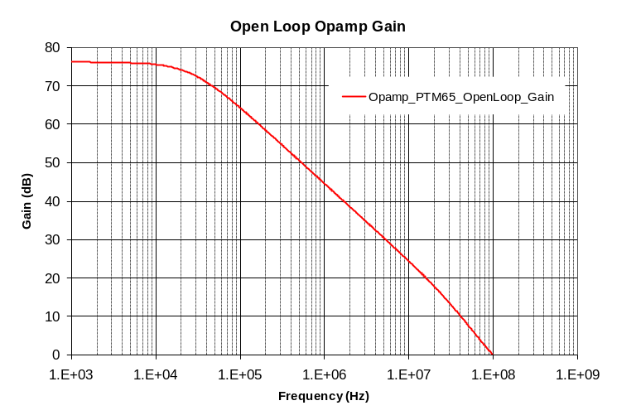
Open-loop gain

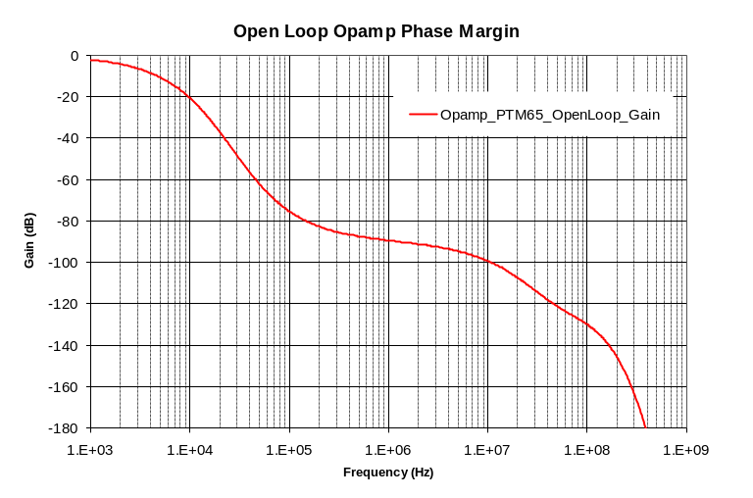
Phase-Margin

